**bootloader Module Description Document**

**1.Overview**

After the system is powered on, it starts by executing the Bootloader in OTP(One Time Programming). After the initialization of the runnable environment of the application system is completed in the Bootloader, it switches to Flash to run the user program.

The Bootloader mainly has the following functions:

* System boot, initialization of related hardware, and switch to Flash for operation
* Upgrade functions (USB/SD/PC/DualBank)
* Flash compatibility driver

This document mainly describes the startup process of the system. For a more detailed description of the Bootloader, please refer to the "BOOT User Guide" document.

**2.The System Boots to Flash Operation**

First, let's take a look at the Bootloader operation process in the OTP of the AP80 series chips:

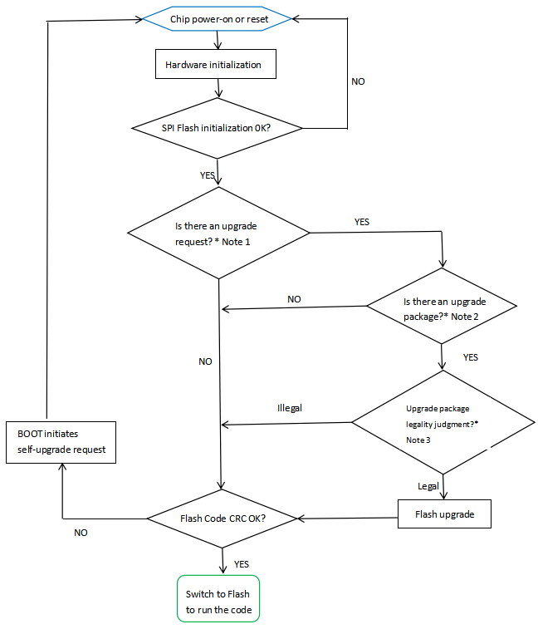

Figure 1 Boot flowchart

From the main line from the blue box to the green box in the above figure, it can be seen that the main steps for system startup are:

* After the system is powered on or reset, the code starts running from the OTP. First, the relevant hardware initialization is carried out, which includes a very important Flash(FSHC) initialization.
* Then, the Bootloader will perform CRC verification on the code part in the Flash, and the verification method used is CRC16.
* If the code CRC in Flash passes, switch to Flash for operation. Otherwise, Boot will issue a self-upgrade and perform a system reset for upgrade detection.

The initialization of Flash(FSHC) is detailed in the "FSHC Module Usage Instructions".

The Bootloader stores compatible drivers for supported Flash models. After the FSHC initialization is completed, the Bootloader will read the ID of the Flash. Based on this ID, information such as the capacity of the Flash can be known, and it can also be determined how to operate the Flash.

CRC check of Flash code is to perform CRC check on the entire code in the Flash. So, how does the Bootloader know the size of the code in the Flash and the CRC value that needs to be compared? All this information exists on Flash. Users can refer to the startup.c file in the SDK, which defines these system-related feature information. As shown below:

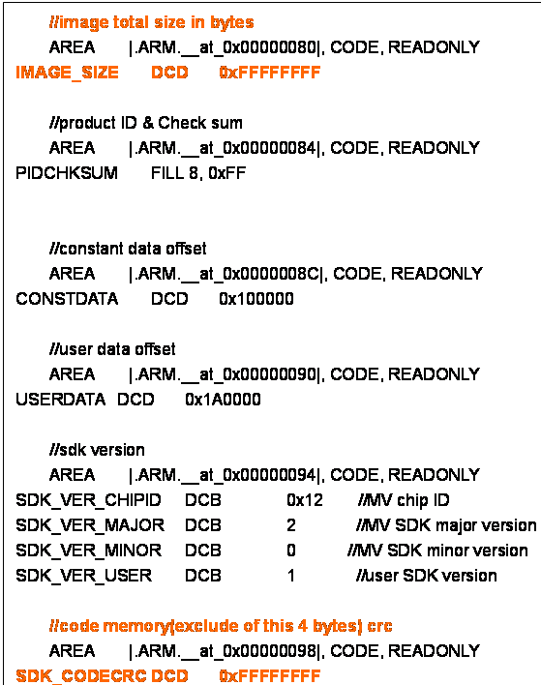

The information marked in red is the code size and CRC information. Among them, the 4 bytes at address 0x80 are where the code size is stored, and the 4 bytes at address 0x98 are the CRC information of the code.

The values of these two addresses are still 0xFFFFFFFF during the program compilation stage, but they only occupy 2*4 bytes of space. When downloading or upgrading the code, the actual size and CRC value of the code will be correctly written by the Downloader or MVA package creation tool.

When the system starts to perform CRC on the Flash code, it will obtain the actual code size and CRC value from these addresses of the Flash, and then perform CRC verification on the actual code content in the Flash.

1. **System Status After Boot Completion**

After the Bootloader of the AP80 series chip finishes starting (before switching to Flash for operation), the system status:

* Clock source: RC48M
* Cache status: Disabled
* WatchDog status: Enabled
* SysTick status: Disabled
* Configure encryption/decryption keys when fetching instructions
* NVM(@176): Non-upgrade process is (-1), and if there is an upgrade process, it is the upgraded state (upgrade successful is 0x57F9B3C8).
* GPIO status: Maintains the status prior to power-on or reset. That is, the bootloader does not change the GPIO status.